Cece Geisler
M7.2 Assignment

city_functions.py
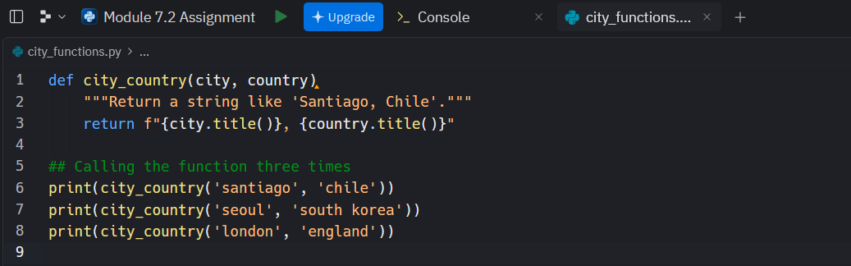
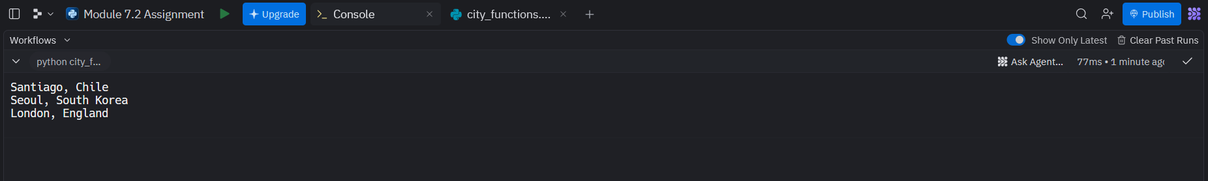
test_cities.py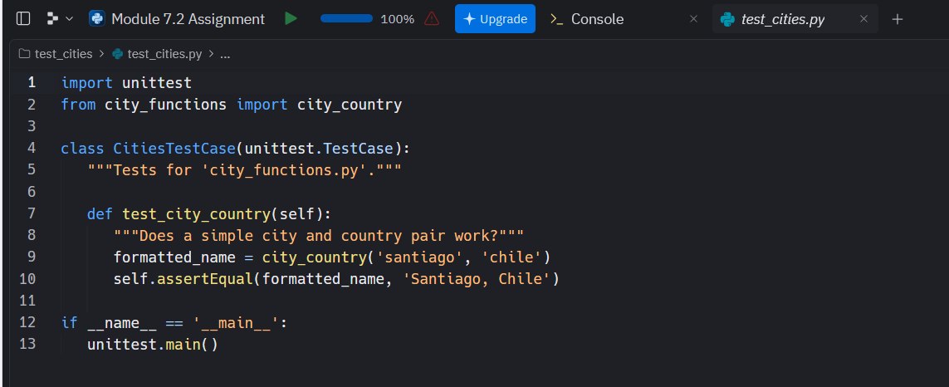
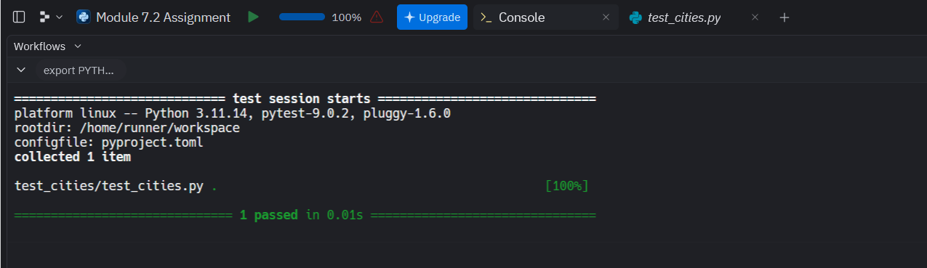

Adding population parameter to city_functions.py
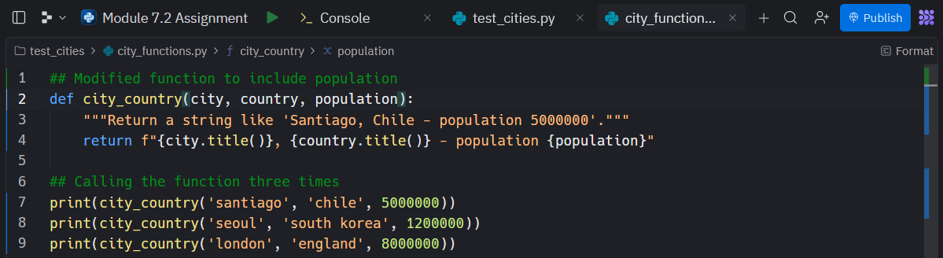
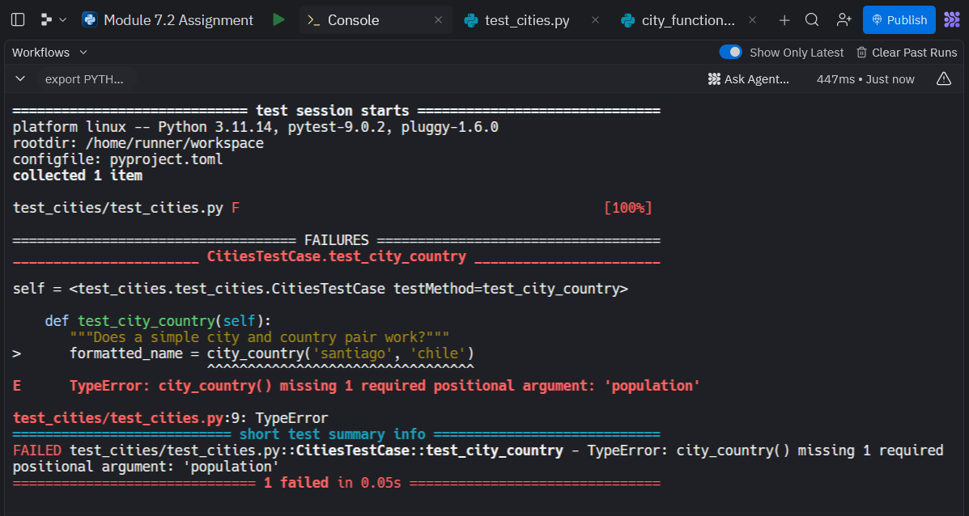

Fixing the population error
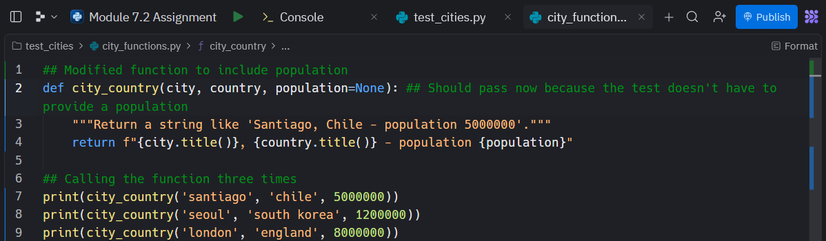
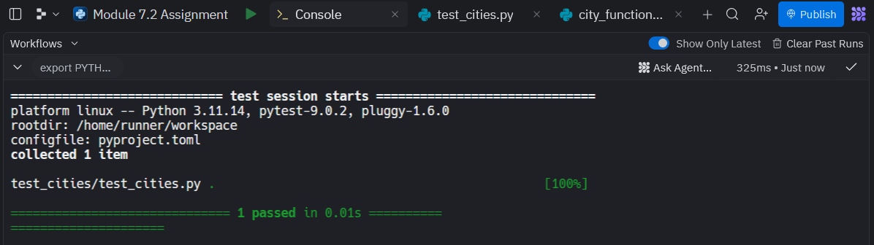

Adding language parameter to city_functions.py
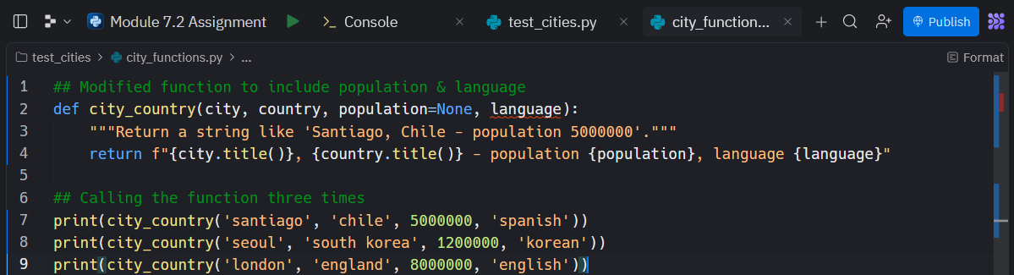
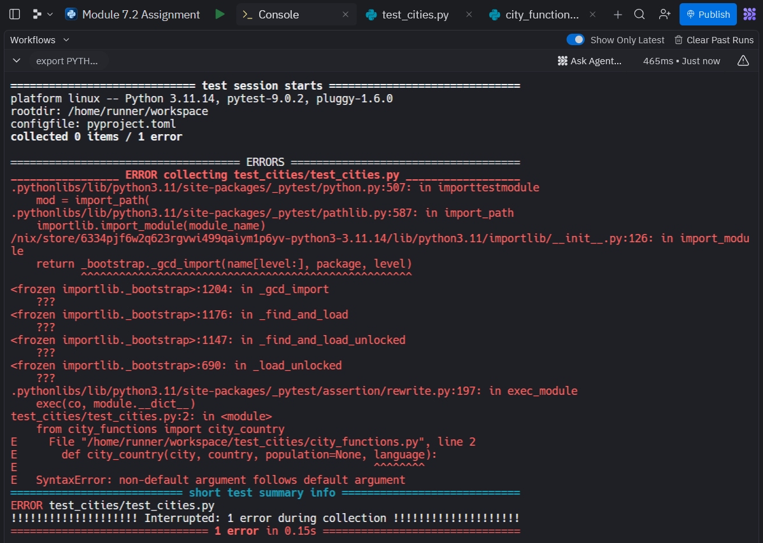

Updated language logic
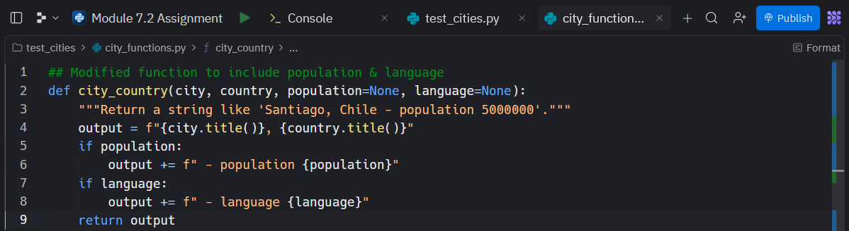
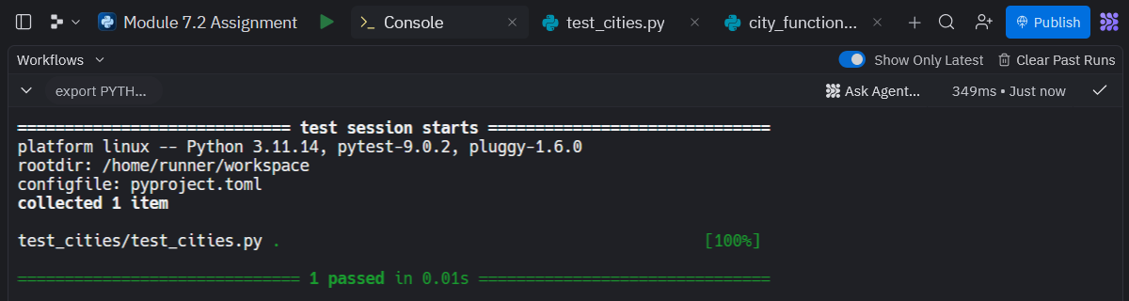

Calling each parameter
